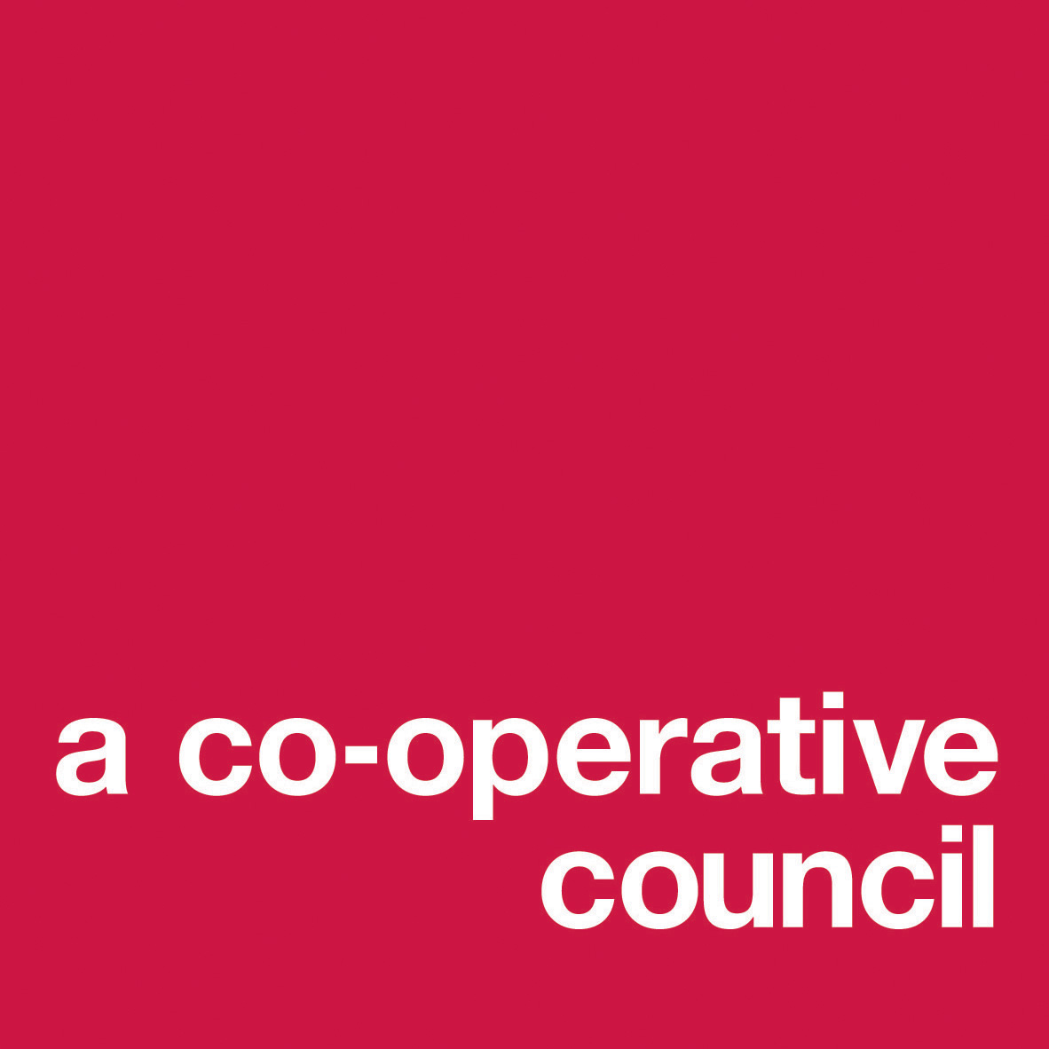
TELFORD AND WREKIN LA
SCHOOL GOVERNORS: DISQUALIFICATION DECLARATION FORM 2021

TO BE COMPLETED BY GOVERNOR:
Title [Mr / Mrs / Miss / Ms / Dr / Revd etc]:

All First Names:

Surname:

All Previous Name(s):

Address:

Post Code: Email Address:

Telephone numbers: (home):
(work):
(mobile):

Date of birth:

School/Academy: Category of Governor:

TO BE COMPLETED BY SCHOOL/ACADEMY:

DBS Certificate No: Date of Issue:

[Governors cannot be appointed without a DBS check]

I declare that I am not disqualified from serving as a school governor and that:

- I am not a registered pupil of the same school;
- I am aged 18 or over at the date of this election or appointment;
- I do not already hold a governorship of the same school;
- (in relation to staff and parent governor elections or appointments only) I have not been disqualified from holding office as a staff or parent governor at the same school through failure to attend meetings without consent;
- I have not within the last twelve months been disqualified through failure to attend meetings without consent from election or appointment as a foundation governor (other than an ex-officio foundation governor), LA governor, co-opted governor, partnership governor or sponsor governor at the same school;
- I am not the subject of a bankruptcy restrictions order or an interim order, and nor has my estate been sequestrated (temporarily repossessed) and the sequestration has not been discharged, annulled or reduced;
- I am not subject to:
- a disqualification order or disqualification undertaking under the Company Directors Disqualification Act 1986;
- a disqualification order under Part 2 of the Companies (Northern Ireland) Order 1989;
- a disqualification undertaking accepted under the Company Directors Disqualification (Northern Ireland) Order 2002; or
- an order made under section 429 (2) (b) of the Insolvency Act 1986 (failure to pay under county court administration order);

- I have not been removed from the office of trustee for a charity by an order made by the Charity Commissioners or the High Court on the grounds of any misconduct or mismanagement in the administration of the charity for which I was responsible or to which I was privy or, to which I contributed or which I facilitated by my conduct or, under section 34 of the Charities and Trustee Investment (Scotland) Act 2005
- I have not been removed from being concerned in the management or control of any body;
- I am not included in the list kept under section 1 of the Protection of Children Act 1999 of those persons considered by the Secretary of State as unsuitable to work with children;
- I am not subject to a direction of the Secretary of State under section 142 of the Education Act 2002 (or any other disqualification, prohibition or restriction which takes effect as if contained in such a direction), prohibiting or restricting my employment as a teacher, other employee or worker with children in any school (ISA list);
- I am not disqualified from working with children under sections 28, 29 or 29A of the Criminal Justice and Court Services Act 2000;
- I am not disqualified from registration under part 10A of the children Act 1989 for child minding or providing day care;
- I am not disqualified from registration under part 3 of the Childcare Act 2006;
- I am not disqualified from being the proprietor of or taking part in the management of any independent school;
- I have not been convicted, whether in the United Kingdom or *elsewhere, of any offence and had passed upon me a sentence of imprisonment whether suspended or not:
either,
  - in the five years prior to the date of this governorship for a period of not less than three months without the option of a fine or,
  - in the twenty years prior to the date of this governorship for a period of not less than two and a half years or,
  - at any time for a period of not less than five years.

(*convictions by courts outside the United Kingdom for offences which would not have been an offence in any part of the United Kingdom can be disregarded).
- I have not been sentenced to a fine, in the five years prior to the date of this governorship, for causing a nuisance or disturbance on educational premises;
- I am not currently disqualified from holding or continuing to hold office as a governor by virtue of having refused a request by a clerk to a governing body to make an application under section 113 of the Police Act 1997 for a criminal records certificate. Nor have I refused such a request by the clerk to this governing body in relation to this governorship.
- I understand that I will be required to apply to the Disclosure & Barring Service (DBS for a disclosure of criminal records if any activities or actions provide “cause for concern”.
- I also understand that failure to:

  - submit a fully completed and signed declaration form;
  - provide appropriate identification;
  - consent to a Section 128 check

will disqualify me from being elected or appointed or re-appointed as a governor.

I will show the original Enhanced DBS Certificate to the school.

Personal Data: Telford & Wrekin Council collects your personal data in connection with your role as a school governor under Article 6(1)(b) of the General Data Protection Regulations 2018 or equivalent United Kingdom legislation. Telford & Wrekin Council will not share any of your personal data with external organisations, unless required to do so by law, or to enable you to be invited to Virtual Meetings and Governor Training through Microsoft Teams. For further details on the council’s privacy arrangements please view the privacy page on the council’s website page.

PRINT NAME: _____________________________________________________________________

SIGNATURE: _____________________________________________ DATE: _________________

