General Data Protection Regulations (GDPR)  Offer to Schools/Parishes/Other Public Sector Bodies | 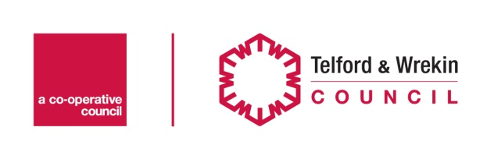
Product 1 - Readiness for GDPR

There will only be 1 tier of offer for this product. Services can be purchased independently

Services Offered | Cost
GDPR Readiness Data Audit (including the provision of specific templates) | Primary School £700-£1000*  Secondary School £1000 – £1,500*  Other Organisations - £1000 - £1,500**
GDPR Training | £127 – 3 hour @ £42.50

*Cost dependent on number of pupils and staff at school. Discount to be applied for schools who have already had a data audit in past 12 months (5%)

**Cost dependant on size of organisation

Product 2 – Data Protection Officer (DPO) and Ongoing GDPR Support

There will be 2 tiers of offer for this product.

Tier 1 – Standard Support

Services Offered | Cost
Provision of DPO services including:  - Informing/advising on obligations to comply with GDPR  - Annual GDPR data audit  - Annual refresher training  - Sign off of Data Protection Impact Assessments  - Support liaison with the Information Commissioners Office  - 5 hours general adhoc GDPR support and advice | Primary School £1650-£2150*  Secondary School £2150 – £2650*  Other Organisations - £2150 - £2650**
Annual Refresher Training | £127 – 3 hour @ £42.50

*Cost dependent on number of pupils and staff at school.

**Cost dependant on size of organisation

Support for the processing of subject access (data protection) requests is not included in the above support package but can be purchased from £42.50 an hour

Tier 2 – Enhanced Support

Services Offered | Cost
Provision of DPO services including:  - Informing/advising on obligations to comply with GDPR  - Complete annual GDPR data audit  - Completion and sign off of Data Protection Impact Assessments  - Support liaison with the Information Commissioners Office  - Support on data breach investigation  - Annual refresher training  - 7.5 hours general adhoc GDPR support and advice | Primary School £2150-£2650*  Secondary School £2650 – £3650*  Other Organisations - £2650 - £3650**

*Cost dependent on number of pupils and staff at school.

**Cost dependant on size of organisation

Support for the processing of subject access (data protection) requests is not included in the above support package but can be purchased from £42.50 an hour

If you are interested in any of the above proposals please contact Rob Montgomery on 01952 383103 or email Robert.Montgomery@telford.gov.uk

