Dear Parent/Carer

At Let’s Dine we are committed to ensure that we are meeting your child’s needs with regard to Allergen information, to ensure we have the correct information for your child’s lunch requirements could I please ask you to complete the below form identifying any allergies or special dietary requirements and return the slip to the school office ASAP.

Kind Regards

Lorna
Catering Group Manger (Let’s Dine)

Childs Name: ___________________________________________ Childs Class: ___________

Please tick any allergens from the list below or state underneath any other allergens/intolerances or cultural requirements

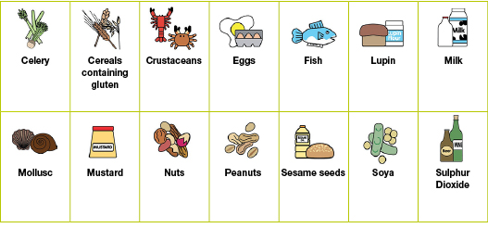

Vegetarian

Any other intolerances/allergies/Cultural requirements:

______________________________________________________________________________

––––––––––––––––––––––––––––––––––––––––––––––––––––––––––––––––––––––––––––––

Parent/Carer Signature: ___________________________________

